Rashmi Thakur
[iDS infotech limited]
Manufacturing performance dashboard

TABLE OF CONTENTS

- Project Overview
- Project Objective
- Dataset Description
  - Production Data
  - Quality & Maintenance Data
  - Cost & Efficiency Data
- Tools used in the Project
- Data Preparation and Modeling
- Dashboard Overview
  - Production Dashboard
  - Quality & Maintenance Dashboard
  - Cost & Efficiency Dashboard
- Recommendation for Future Improvement
- Conclusion

PROJECT OVERVIEW
Introduction
In modern manufacturing environments, monitoring production performance, operational efficiency, and cost management is essential for maintaining competitiveness and achieving business goals. Organizations require reliable data insights to track production output, machine performance, product quality, and operational costs.
The Manufacturing Performance Dashboard has been developed using Microsoft Power BI to provide an interactive and data-driven visualization platform for monitoring key manufacturing metrics. This dashboard integrates production, quality, maintenance, and cost-related data into a centralized system, enabling stakeholders to quickly analyze operational performance.
The dashboard consists of three main analytical sections: Production Performance, Quality & Maintenance Analysis, and Cost & Efficiency Monitoring. Each section presents key performance indicators (KPIs), trends, and comparisons through intuitive visualizations such as line charts, bar charts, gauges, and KPI cards.
By using interactive filters and slicers, users can analyze data based on plant location, product category, time period, and other operational parameters. This allows managers and analysts to identify production trends, detect operational inefficiencies, monitor product quality, and evaluate cost structures.
Overall, this dashboard helps decision-makers gain actionable insights into manufacturing operations, enabling them to improve productivity, optimize resources, reduce downtime, and enhance overall operational efficiency.

PROJECT OBJECTIVE

The overall objective of this project is to design and develop an interactive Manufacturing Performance Dashboard using Microsoft Power BI that provides comprehensive insights into manufacturing operations and performance. The dashboard aims to centralize key manufacturing data and transform it into meaningful visualizations that support efficient monitoring and decision-making.
This dashboard focuses on analyzing critical aspects of manufacturing such as production performance, machine utilization, product quality, maintenance activities, and operational costs. By integrating these different datasets into a single analytical platform, the dashboard enables stakeholders to gain a holistic view of manufacturing operations.
The solution is designed to help managers and operational teams monitor production output compared to targets, track downtime and machine efficiency, analyze defective units and rejection rates, and evaluate maintenance costs and breakdown incidents. Additionally, the dashboard provides insights into cost efficiency, cost per unit, and on-time production performance, which are essential for optimizing overall manufacturing productivity.
Interactive filters and slicers allow users to dynamically analyze data based on parameters such as plant location, product category, year, and time period, enabling deeper analysis and better operational planning. By presenting key metrics through intuitive visuals such as KPI cards, line charts, bar charts, and gauges, the dashboard makes complex manufacturing data easy to interpret.
Ultimately, the objective of this project is to create a data-driven decision support tool that helps organizations identify performance gaps, improve operational efficiency, reduce downtime, enhance product quality, and optimize manufacturing costs.

DATASET DESCRIPTION
The dataset used for this project consists of sample/mock manufacturing data designed to simulate real-world manufacturing operations. The data includes information related to production activities, product quality, machine maintenance, and operational costs. These datasets were structured to support the development of an interactive Power BI dashboard that analyzes key manufacturing performance indicators.
The dataset is divided into three main categories: Production Data, Quality & Maintenance Data, and Cost & Efficiency Data. Each dataset captures specific operational aspects of the manufacturing process.
3.1 Production Data
The Production Data dataset contains information related to daily production activities across different manufacturing plants. This dataset is used to monitor production output, track production targets, and analyze machine utilization and downtime.
Column Name | Description
Date | The data on which production activity was recorded.
Plant/Location | Manufacturing plant where production occurred.
Product Category | Category or type of product being manufactured.
Unit Produced | Total number of units produced during the given period.
Production Target | Expected production quantity set as the target.
Downtime(hours) | Total hours when machine were not operational.
Machine Utilization (%) | Percentage of machine usage during production.
Rejection Rate | Percentage of rejected or defective units.
This dataset helps analyze production performance and identify whether manufacturing plants are meeting their production goals efficient.

3.2 Quality & Maintenance Data

The Quality & Maintenance dataset provides information related to product quality and machine maintenance activities. This dataset is useful for monitoring product defects, analyzing rejection rates, and evaluating maintenance costs.

Column Name | Description
Date | Date of quality inspection or maintenance activity.
Defective Units | Number of units identified as defective.
Quality Inspection Score | Quality rating assigned during inspection.
Maintenance Cost | Cost incurred foe machine maintenance.
Breakdown Incidents | Number of machine breakdown recorded.
Preventive Maintenance Completed | Indicates whether preventive maintenance was completed.

This dataset helps in identifying quality issues and understanding the impact of maintenance activities on production efficiency.
3.3 Cost & Efficiency Data

The Cost & Efficiency dataset contains financial and operational performance metrics related to manufacturing processes. This dataset helps evaluate cost distribution and production efficiency.

Column Name | Description
Date | Date when cost or efficiency data was recorded.
Labor Cost | Cost associated with workforce involved in production.
Material Cost | Cost of raw material used in manufacturing.
Operational Cost | Overall operational expenses incurred during production.
Cost per Unit | Cost required to produce a single unit.
On – Time Production (%) | Percentage of production completed within the scheduled time.
Capacity Utilization (%) | Percentage of manufacturing capacity being used.

This dataset enables analysis of production costs and helps identify opportunities to improve operational efficiency and cost optimization.

TOOLS USED IN THE PROJECT

Microsoft Power BI
Microsoft Power BI is a powerful business intelligence and data visualization tool used to transform raw data into interactive dashboards and meaningful insights.
In this project, Power BI was used to import datasets, perform data modeling, create relationships between tables, and design interactive visualizations.
Power BI enables users to analyze large datasets efficiently by using charts, KPI cards, gauges, and slicers. It also provides interactive filtering capabilities that allow users to explore data dynamically based on parameters such as plant location, product category, and time period.
The Manufacturing Performance Dashboard developed in this project utilizes Power BI features such as data modeling, calculated measures, interactive visuals, and dashboard navigation to monitor production performance, quality metrics, and cost efficiency.

Microsoft Excel
Microsoft Excel was used to create and organize the sample dataset used in the dashboard. The datasets were structured into multiple sheets representing production data, quality and maintenance data, and cost and efficiency data.
Excel helped in preparing the dataset in a structured tabular format before importing it into Power BI for analysis and visualization.

DATA PREPARATION AND MODELING

Data Preparation
The dataset was first organized in Microsoft Excel where the data was structured into three main categories: Production Data, Quality & Maintenance Data, and Cost & Efficiency Data. Each dataset contained relevant attributes such as date, plant location, product category, production metrics, quality indicators, and cost-related information.
After preparing the dataset, the Excel file was imported into Power BI Desktop using the Get Data feature. The required tables were selected and loaded into Power BI for further processing. Basic data validation steps were performed to ensure correct data types, column names, and structured data format.

Data Modeling
Once the data was imported, a data model was created in Power BI to establish relationships between different tables. A Dim Date table was used as a central date dimension to enable time-based analysis across the dashboard.
The relationships were established between the DimDate table and the Production Data, Quality & Maintenance Data, and Cost & Efficiency Data tables using the Date field. This structure follows a star schema model, which improves performance and ensures efficient filtering and aggregation of data.
This data modeling approach allows the dashboard to support time-based filtering, consistent data analysis, and dynamic interaction between visuals across different dashboard pages.

Relationship Structure
A DimDate table is used as a central table to establish relationships with the other datasets based on the Date field. This structure follows a star schema model, which improves performance and simplifies data analysis.

Role of the Date Dimension Table
The DimDate table plays a crucial role in enabling time intelligence within the dashboard. It includes attributes such as Date, Month Name, Month Number, Month Year, and Quarter, which allow users to analyze manufacturing performance across different time periods.
By linking the DimDate table with all major datasets, the dashboard ensures that time-based filters and visualizations work consistently across all pages.

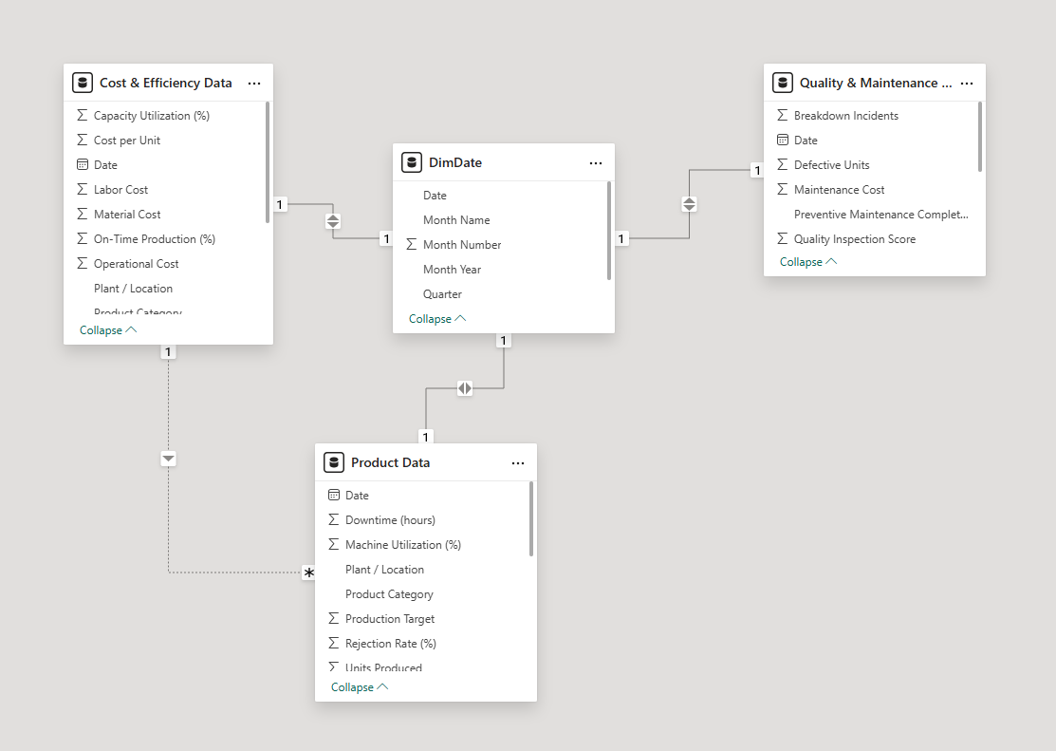

Dashboard Overview

The Manufacturing Performance Dashboard was developed using Microsoft Power BI to provide an interactive platform for monitoring key manufacturing operations. The dashboard integrates production, quality, maintenance, and cost-related data to help users analyze overall manufacturing performance.
The dashboard is divided into three main pages: Production, Quality & Maintenance, and Cost & Efficiency. Each page focuses on a specific aspect of manufacturing operations and presents key performance indicators (KPIs) through visualizations such as charts, KPI cards, gauges, and tables.
Interactive filters and slicers allow users to analyze data by plant location, product category, and time period, enabling deeper analysis and better decision-making.
Overall, the dashboard helps managers monitor production performance, evaluate product quality, and analyze operational costs in order to improve efficiency and support data-driven decision making.
Dashboard Pages & Explanation
6.1 Production Dashboard

Purpose
The purpose of the Production Dashboard is to monitor manufacturing output and operational efficiency across different plants. It helps stakeholders compare actual production with production targets, evaluate machine utilization, analyze downtime, and understand how effectively the available manufacturing capacity is being used.
This dashboard enables production managers to quickly identify performance trends, detect operational inefficiencies, and make informed decisions to improve manufacturing productivity.
Key Metrics (KPIs)
Total Production – 1.28M
This KPI shows the total number of units produced across all plants during the selected time period.
Production Variance – -101K
This metric represents the difference between the production target and the actual production. A negative variance indicates that production is below the planned target.
Downtime – 10.49%
Downtime measures the percentage of time when machines were not operational due to maintenance, breakdowns, or other interruptions.
Machine Utilization – 77.20%
This KPI shows the percentage of machine capacity that is actively used for production.
Capacity Utilization – 77.3%
Capacity utilization indicates how efficiently the manufacturing plant is using its total available production capacity.

Visualizations and Insights

1. Units Produced vs Target over Time
This line chart compares the actual production units with the production target for each month.
Insights:
Production fluctuates across months but remains close to the target level.
Some months show a gap between actual production and targets, contributing to the negative production variance.

2. Production by Plant
This horizontal bar chart shows the total production output of each manufacturing plant.
Insights:
Plant A has the highest production with 451K units.
Plant B follows with 422K units.
Plant C has the lowest production with 407K units.
This indicates that Plant A is currently the most productive facility.

3. Rejection Rate by Month

This column chart displays the percentage of defective or rejected units produced each month.
Insights:
The rejection rate fluctuates between 3% and 3.7%.
The lowest rejection rate is observed in May (~3.03%), indicating better quality performance during that period.
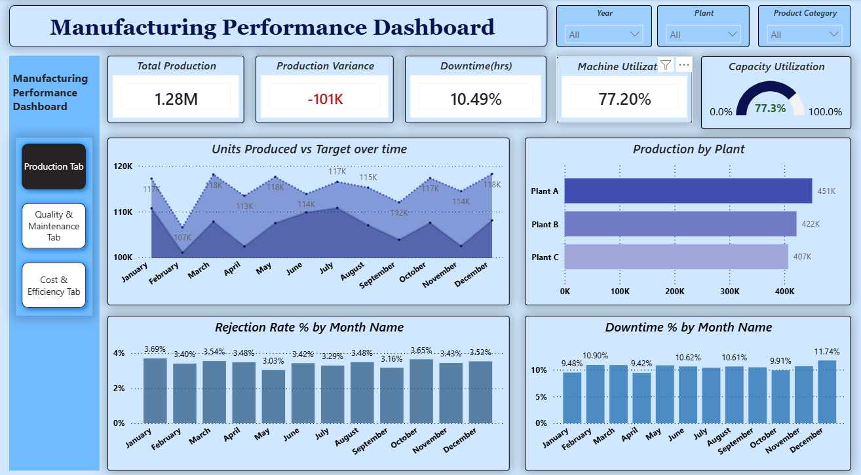
Fig 6.1

